**Report of Structure and Interpretation of Computer Programs**

Chonbuk National University

Department of Computer Science

201514768

임유택

**Problem 1**

**code;**

#lang racket

;; By default, Racket doesn't have set-car! and set-cdr! functions. The

;; following line allows us to use those:

(require r5rs)

(require rackunit)

;; Unfortunately, it does this by making cons return a "mutable pair"

;; instead of a "pair", which means that many built-ins may fail

;; mysteriously because they expect a pair, but get a mutable pair.

;; Re-define a few common functions in terms of car and friends, which

;; the above line make work with mutable pairs.

(define first car)

(define rest cdr)

(define second cadr)

(define third caddr)

(define fourth cadddr)

;; We also tell DrRacket to print mutable pairs using the compact syntax

;; for ordinary pairs.

(print-as-expression #f)

(print-mpair-curly-braces #f)

(define (find-assoc key table)

(cond

((null? table) 'ERROR)

((equal? key (caar table)) (cadar table))

(else (find-assoc key (rest table)))))

(define (add-assoc key val alist)

(cons (list key val) alist))

(define table-tag 'table)

(define (make-table) (cons table-tag null))

(define (table? table1)

(if (equal? (first table1) 'table)

#t

#f))

(define (table-get tbl key)

(if (table? tbl)

(find-assoc key (rest tbl))

#f))

(define (table-put! tbl key val)

(if (table? tbl)

(set-cdr! tbl (add-assoc key val (rest tbl)))

#f))

(define (table-has-key? tbl key)

(if (table? tbl)

(fortf-find-assoc key (rest tbl))

#f))

(define (fortf-find-assoc key table)

#f(cond

[(null? table) #f]

[(eq? key (caar table)) #t]

[else (fortf-find-assoc key (rest table))]))

;; Allow this file to be included from elsewhere, and export all defined

;; functions from it.

(provide (all-defined-out))

Problem1

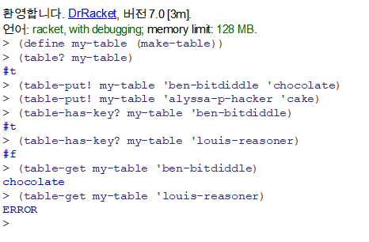

test-case1

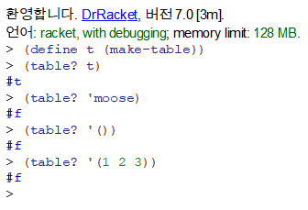

test-case2

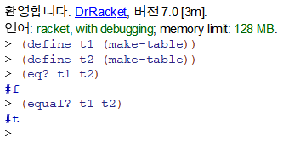

test-case3

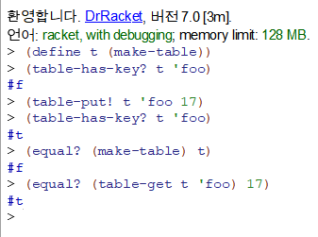

test-case4

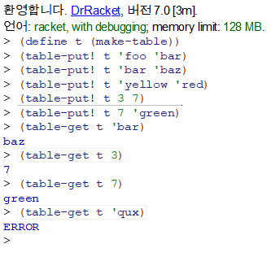

test-case5

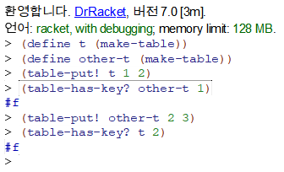

test-case6

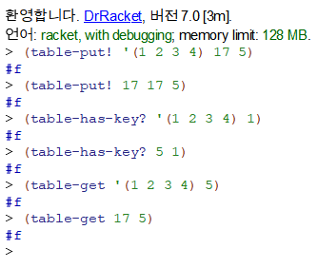

**Problem 2**

**code;**

#lang racket

(define (fib n)

(if (< n 2)

n

(+ (fib (- n 1)) (fib (- n 2)))))

(define callnum 0)

(define (make-monitored fib)

(lambda (n)

(cond [(equal? n 'how-many-calls?) callnum]

[(equal? n 'reset-call-count) (set! callnum 0)]

[else

(set! callnum (+ callnum 1))

(if (< n 2)

n

(+ ((make-monitored fib) (- n 1)) ((make-monitored fib) (- n 2))))])))

(fib 8)

(set! fib (make-monitored fib))

(fib 8)

(fib 'how-many-calls?)

(fib 8)

(fib 'how-many-calls?)

(fib 'reset-call-count)

(fib 'how-many-calls?)

Problem2

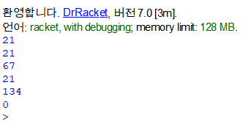

**Problem 3**

**code;**

#lang racket

;; By default, Racket doesn't have set-car! and set-cdr! functions. The

;; following line allows us to use those:

(require r5rs)

(require rackunit)

;; Unfortunately, it does this by making cons return a "mutable pair"

;; instead of a "pair", which means that many built-ins may fail

;; mysteriously because they expect a pair, but get a mutable pair.

;; Re-define a few common functions in terms of car and friends, which

;; the above line make work with mutable pairs.

(define first car)

(define rest cdr)

(define second cadr)

(define third caddr)

(define fourth cadddr)

;; We also tell DrRacket to print mutable pairs using the compact syntax

;; for ordinary pairs.

(print-as-expression #f)

(print-mpair-curly-braces #f)

(define table-tag 'table)

(define (make-table) (cons table-tag null))

(define table (make-table))

(define (add-assoc key val alist)

(cons (list key val) alist))

(define (fib n)

(if (< n 2)

n

(+ (fib (- n 1)) (fib (- n 2)))))

(define callnum 0)

(define (make-monitored fib)

(lambda (n)

(cond [(equal? n 'how-many-calls?) callnum]

[(equal? n 'reset-call-count) (set! callnum 0)]

[else

(set! callnum (+ callnum 1))

(if (< n 2)

n

(+ ((make-monitored fib) (- n 1)) ((make-monitored fib) (- n 2))))])))

(define (make-num-calls-table fib n)

((make-monitored fib) n)

(set-cdr! table (add-assoc n callnum (rest table)))

(set! callnum 0)

(if (< n 2)

table

(make-num-calls-table fib (- n 1))))

;; Allow this file to be included from elsewhere, and export all defined

;; functions from it.

(provide (all-defined-out))

Problem3

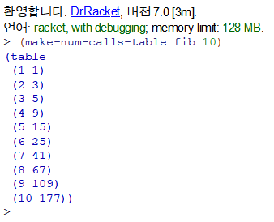

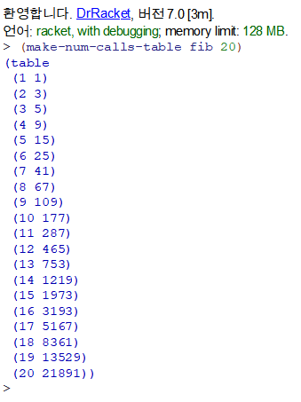

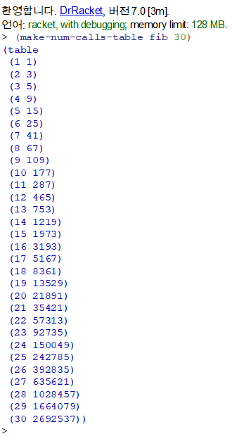

**Problem 4**

**code;**

#lang racket

;; By default, Racket doesn't have set-car! and set-cdr! functions. The

;; following line allows us to use those:

(require r5rs)

(require rackunit)

;; Unfortunately, it does this by making cons return a "mutable pair"

;; instead of a "pair", which means that many built-ins may fail

;; mysteriously because they expect a pair, but get a mutable pair.

;; Re-define a few common functions in terms of car and friends, which

;; the above line make work with mutable pairs.

(define first car)

(define rest cdr)

(define second cadr)

(define third caddr)

(define fourth cadddr)

;; We also tell DrRacket to print mutable pairs using the compact syntax

;; for ordinary pairs.

(print-as-expression #f)

(print-mpair-curly-braces #f)

;;n을 입력하면 n까지의 rusursive를 이용한 fib값을 테이블에 put.

;;n보다 작은 수가 들어오면 recursive 이용이 아닌 table에서 get. (효율적)

;;n보다 큰 수 m이 들어오면 m부터 n까지 recursive를 이용해 fib값을 구하고 테이블에 put

;;지금까지 사용자가 입력한 수 보다 작은 값을 입력하면 table에서 가져와 비효율적인 recursive를 하지 않음.

(define table-tag 'table)

(define (make-table) (cons table-tag null))

(define table (make-table))

(define (add-assoc key val alist)

(cons (list key val) alist))

(define (find-assoc key table)

(cond

((null? table) 'ERROR)

((equal? key (caar table)) (cadar table))

(else (find-assoc key (rest table)))))

(define (table-get tbl key)

(if (table? tbl)

(find-assoc key (rest tbl))

#f))

(define (table? table1)

(if (equal? (first table1) 'table)

#t

#f))

(define (table-has-key? tbl key)

(if (table? tbl)

(fortf-find-assoc key (rest tbl))

#f))

(define (fortf-find-assoc key table)

#f(cond

[(null? table) #f]

[(eq? key (caar table)) #t]

[else (fortf-find-assoc key (rest table))]))

(define (fib n)

(if (< n 2)

n

(+ (fib (- n 1)) (fib (- n 2)))))

(define (formemoizefib n)

(if (< n 2)

n

(+ (formemoizefib (- n 1)) (formemoizefib (- n 2)))))

(define callnum 0)

(define (make-monitored fib)

(lambda (n)

(cond [(equal? n 'how-many-calls?) callnum]

[(equal? n 'reset-call-count) (set! callnum 0)]

[else

(set! callnum (+ callnum 1))

(if (< n 2)

n

(+ ((make-monitored fib) (- n 1)) ((make-monitored fib) (- n 2))))])))

(define (make-num-calls-table fib n)

((make-monitored fib) n)

(set-cdr! table (add-assoc n callnum (rest table)))

(set! callnum 0)

(if (< n 2)

table

(make-num-calls-table fib (- n 1))))

(define room-num 0)

(define (search-and-add n table)

(if (eq? (table-has-key? table n) #f)

(set-cdr! table (add-assoc n (formemoizefib n) (rest table)))

(table-get table n)))

(define (memoize fib)

(lambda (n)

(set! room-num 0)

(set! room-num (+ room-num 1))

(if (null? (rest table))

(set-cdr! table (add-assoc n (formemoizefib n) (rest table)))

(search-and-add n table))

(if (< n 2)

(table-get table room-num)

((running-memoize fib) (- n 1)))))

(define (running-memoize fib)

(lambda (n)

(set! room-num (+ room-num 1))

(if (null? (rest table))

(set-cdr! table (add-assoc n (formemoizefib n) (rest table)))

(search-and-add n table))

(if (< n 2)

(table-get table room-num)

((running-memoize fib) (- n 1)))))

(set! fib (memoize fib))

;; Allow this file to be included from elsewhere, and export all defined

;; functions from it.

(provide (all-defined-out))

Problem4

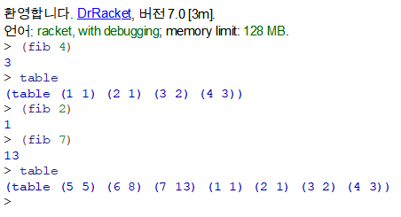

**Problem 5**

**code;**

#lang racket

(define (add-1 x) (+ x 1))

(define (advise func a b) (lambda(n) (a) (b) (func n)))

(define advised-add-1

(advise add-1

(lambda () (displayln "calling add-1"))

(lambda () (displayln "add-1 done"))))

Problem5

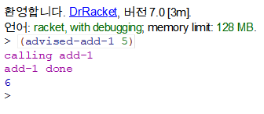

**Problem 6**

**code;**

#lang racket

;; By default, Racket doesn't have set-car! and set-cdr! functions. The

;; following line allows us to use those:

(require r5rs)

(require rackunit)

;; Unfortunately, it does this by making cons return a "mutable pair"

;; instead of a "pair", which means that many built-ins may fail

;; mysteriously because they expect a pair, but get a mutable pair.

;; Re-define a few common functions in terms of car and friends, which

;; the above line make work with mutable pairs.

(define first car)

(define rest cdr)

(define second cadr)

(define third caddr)

(define fourth cadddr)

;; We also tell DrRacket to print mutable pairs using the compact syntax

;; for ordinary pairs.

(print-as-expression #f)

(print-mpair-curly-braces #f)

(define table-tag 'table)

(define (make-table) (cons table-tag null))

(define table (make-table))

(define (add-assoc key val alist)

(cons (list key val) alist))

(define (find-assoc key table)

(cond

((null? table) 'ERROR)

((equal? key (caar table)) (cadar table))

(else (find-assoc key (cdr table)))))

(define (table-get tbl key)

(if (table? tbl)

(find-assoc key (cdr tbl))

#f))

(define (table? table1)

(if (equal? (car table1) 'table)

#t

#f))

(define (table-has-key? tbl key)

(if (table? tbl)

(fortf-find-assoc key (cdr tbl))

#f))

(define (fortf-find-assoc key table)

#f(cond

[(null? table) #f]

[(eq? key (caar table)) #t]

[else (fortf-find-assoc key (cdr table))]))

(define (fib n)

(if (< n 2)

n

(+ (fib (- n 1)) (fib (- n 2)))))

(define callnum 0)

(define (make-monitored fib)

(lambda (n)

(cond [(equal? n 'how-many-calls?) callnum]

[(equal? n 'reset-call-count) (set! callnum 0)]

[else

(set! callnum (+ callnum 1))

(if (< n 2)

n

(+ ((make-monitored fib) (- n 1)) ((make-monitored fib) (- n 2))))])))

(define (make-num-calls-table fib n)

((make-monitored fib) n)

(set-cdr! table (add-assoc n callnum (cdr table)))

(set! callnum 0)

(if (< n 2)

table

(make-num-calls-table fib (- n 1))))

(define room-num 0)

(define (search-and-add n table)

(if (eq? (table-has-key? table n) #f)

(set-cdr! table (add-assoc n (fib n) (cdr table)))

(table-get table n)))

(define (memoize fib)

(set! room-num (+ room-num 1))

(lambda (n)

(if (null? (cdr table))

(set-cdr! table (add-assoc n (fib n) (cdr table)))

(search-and-add n table))

(if (< n 2)

(table-get table room-num)

((memoize fib) (- n 1)))))

(define (advise1 func fibnum a b c d) (a) (b) (c) (d))

(define (make-monitored-with-advice fib)

(lambda (n)

(set! callnum 0)

(advise1 make-monitored

((make-monitored fib) n)

(lambda () (display "Num calls: "))

(lambda () (display callnum))

(lambda () (display "\n"))

(lambda () (display ((make-monitored fib) n)))

)))

(set! fib (make-monitored-with-advice fib))

;; Allow this file to be included from elsewhere, and export all defined

;; functions from it.

(provide (all-defined-out))

Problem6

